**Gin Rummy Showcase**

This is the first screen the user will see when starting the client.

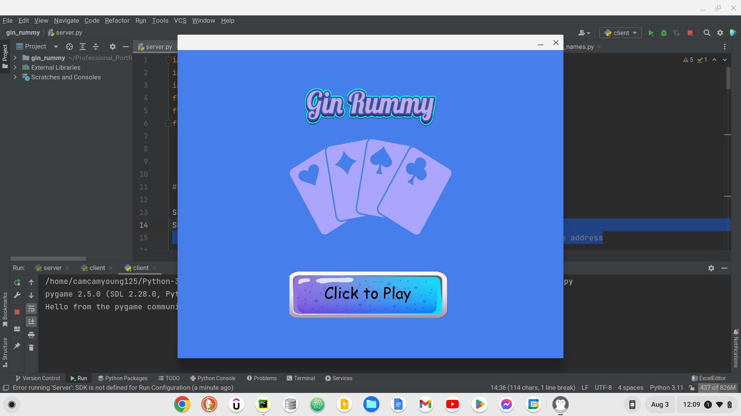

After clicking the button a loading bar will display until another player joins the server.

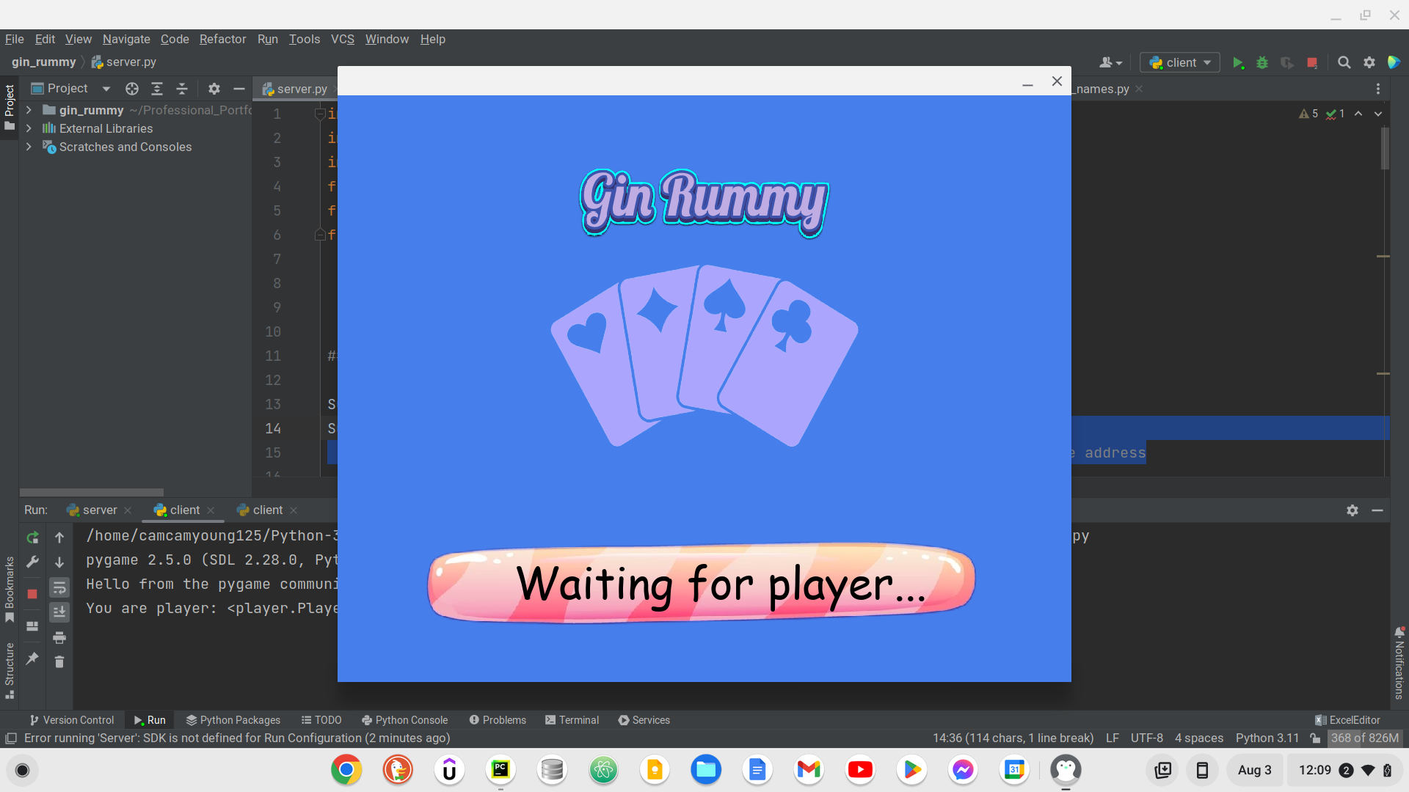

Once both players have connected, this is the first screen each player sees.

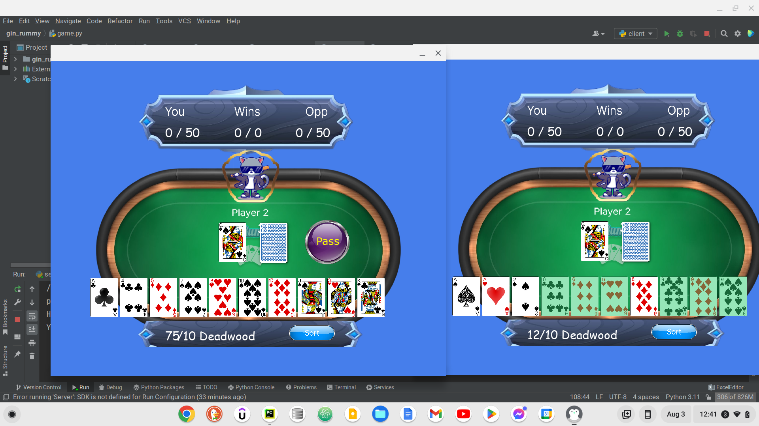  
A random player, for the first turn, will have the option to pass on the middle card with the pass button.

Both players can use the sort button to automatically sort their hand in numerical order. Both players can also swap their cards manually by selecting a card, which will be signified by a black rectangle around the card, then selecting a different card in their hand.

After the first turn is played the active player will have a choice whether to pick up from the deck or pick up the middle card.

The white number on the deck signifies how many cards are left in the deck.

The player then chooses a card to put back into the middle thus ending their turn.

When cards are in sets or runs in the hand, the cards will be highlighted green and there values will be taken away from the player’s deadwood score.

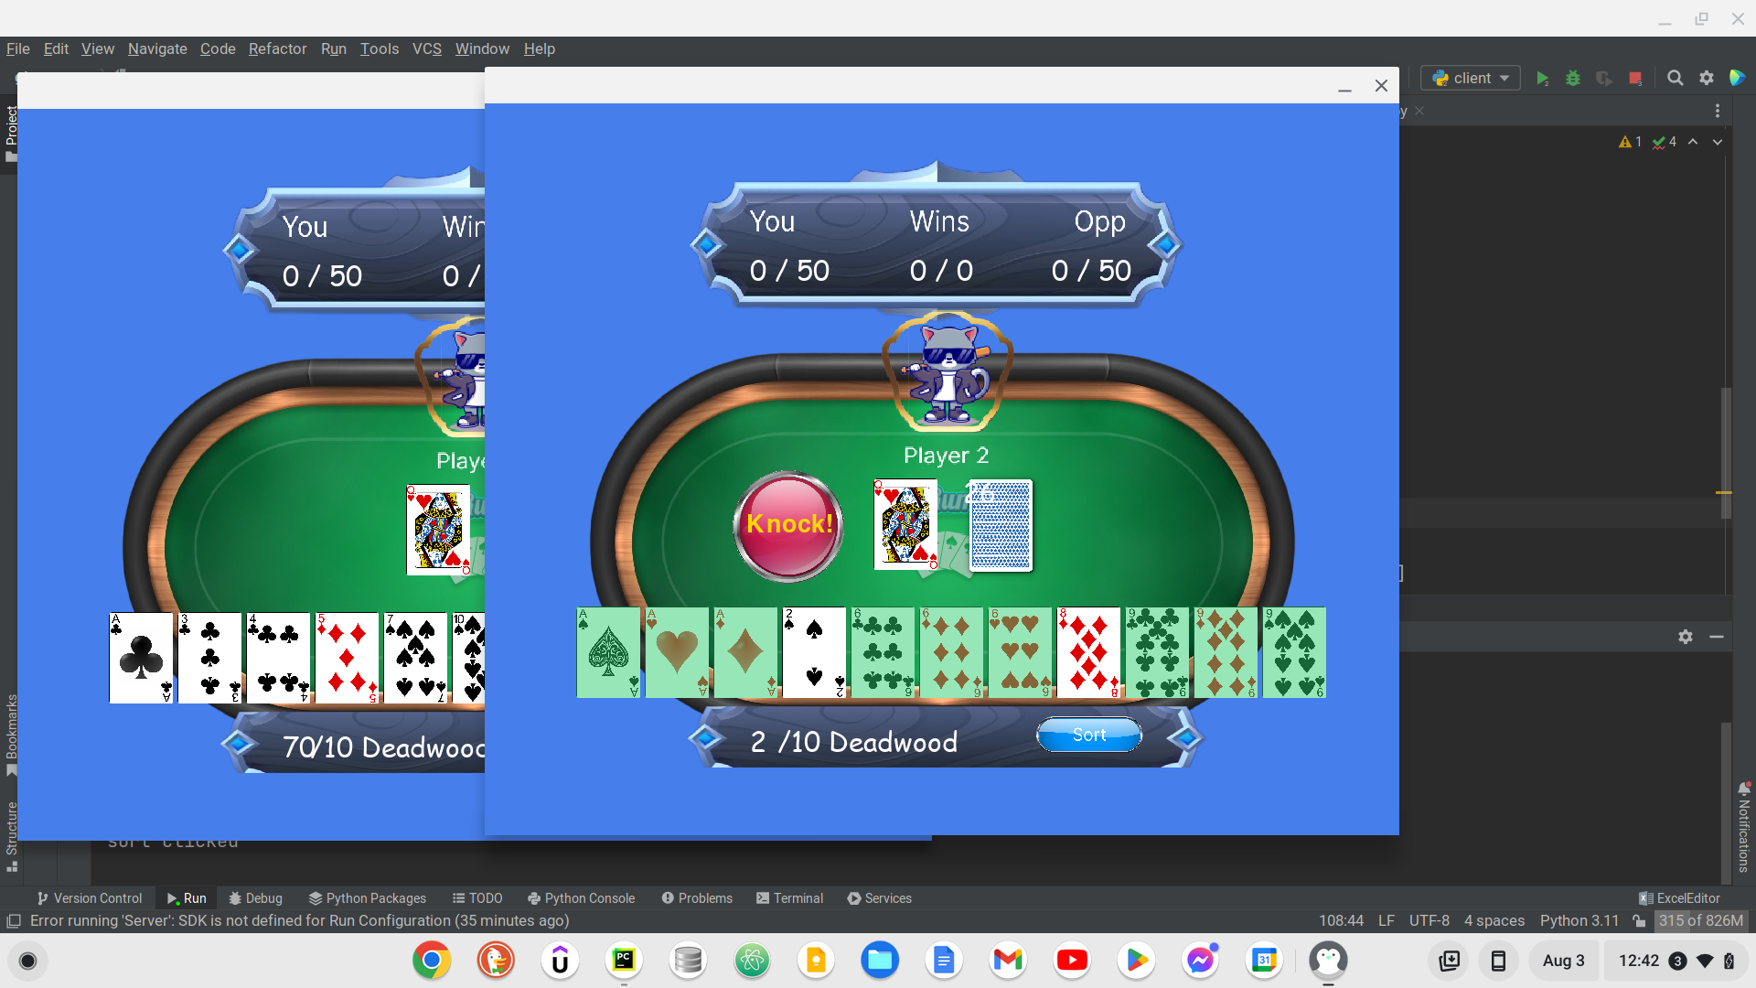

When a player has a deadwood value of 10 or less, a win button will be displayed. A player can decide to press this button and possibly win the round.



After a win button is clicked the scores are tallied up and each player’s hands will be displayed like so.  
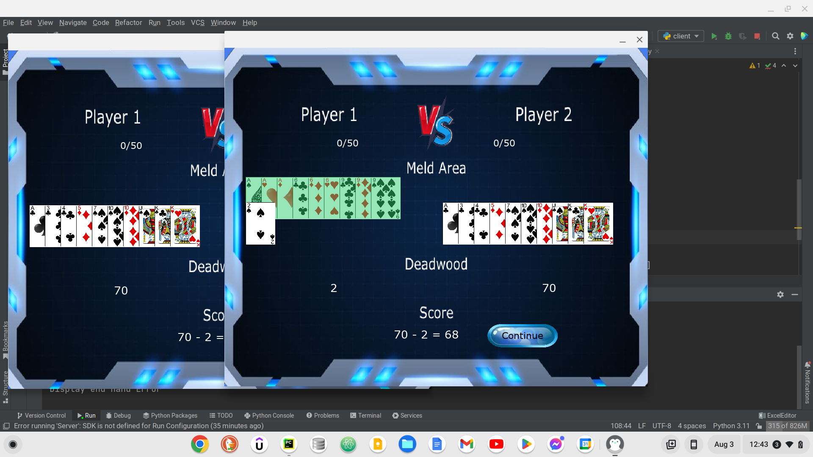

After each player has clicked on the continue button. If a player's score has not reached the target score (50 in this case) then another round begins and the score will be displayed.

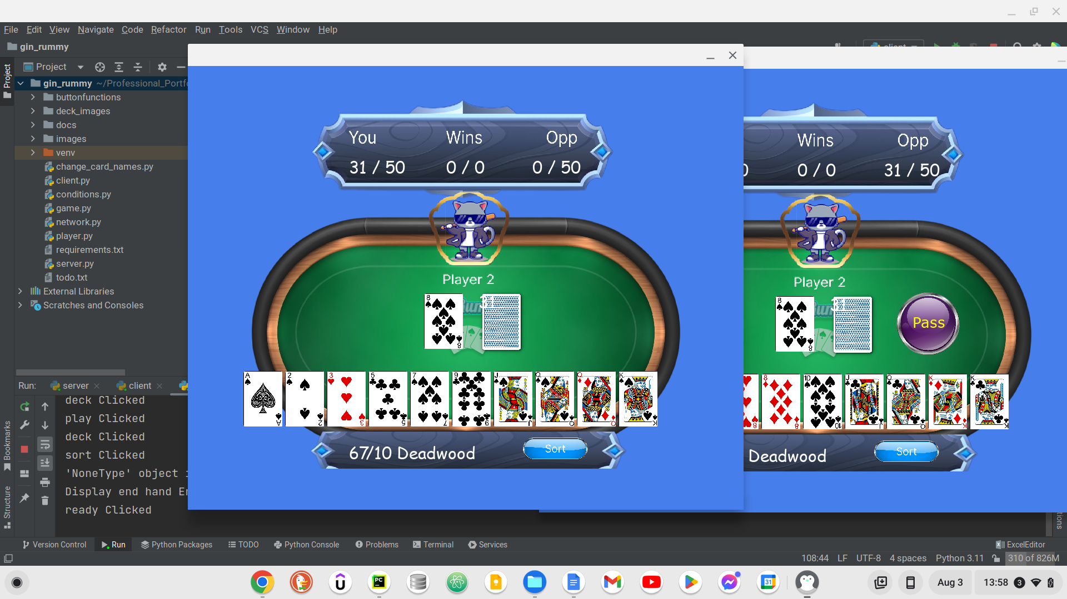

If a player's score has reached the target score, that player will have won the game and the screen will display this.

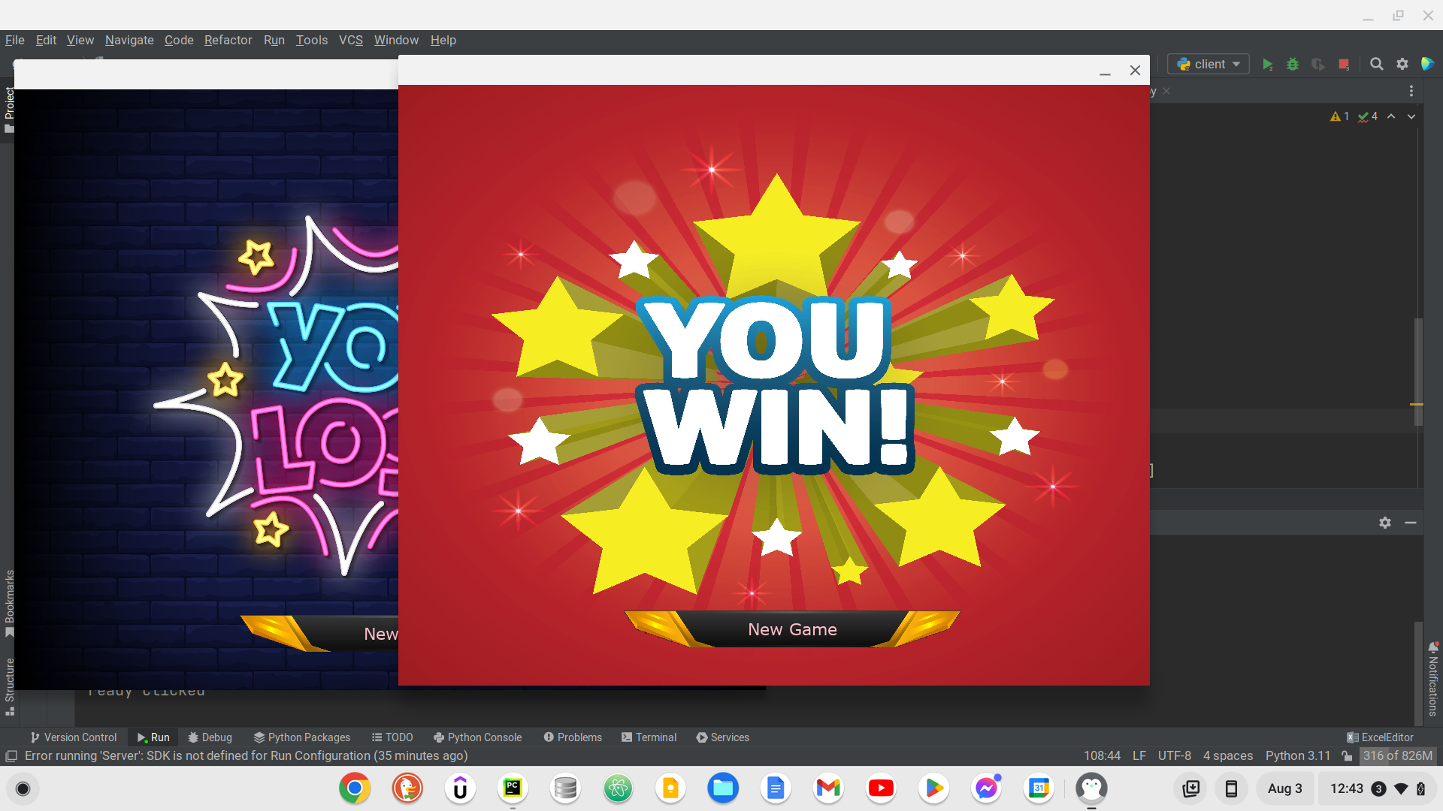

If ‘New Game’ is clicked by both players a new game will start with the updated wins value.

